**Screenshots of Movie Matcher Project**

Screenshot of Terminal in Pycharm

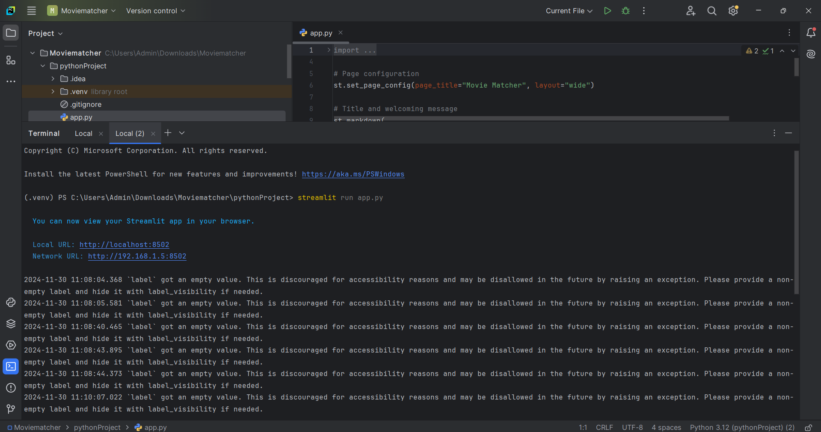

Screenshots of the Web app

